jQuery/AJAX/PHP/MYSQL Based Web Chat App

Build a live interactive chat App using the combination of the above mentioned technologies.

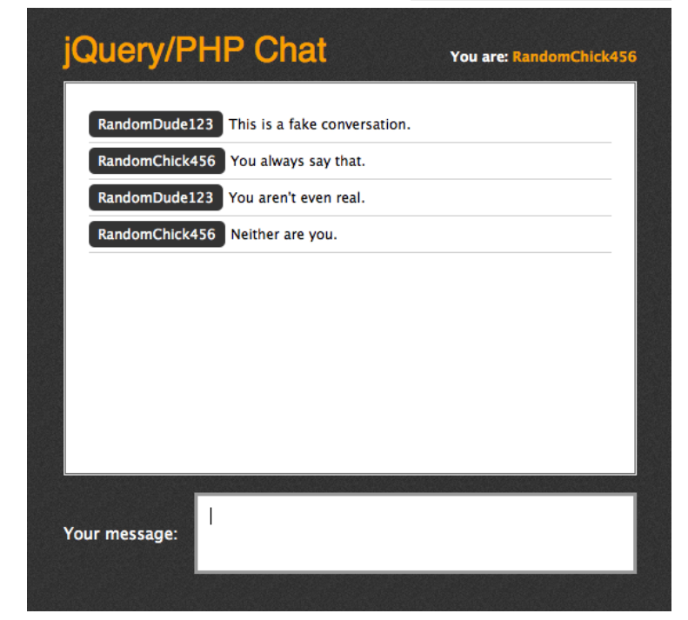

Note, read the following function

setInterval